**LỌC NHIỄU**

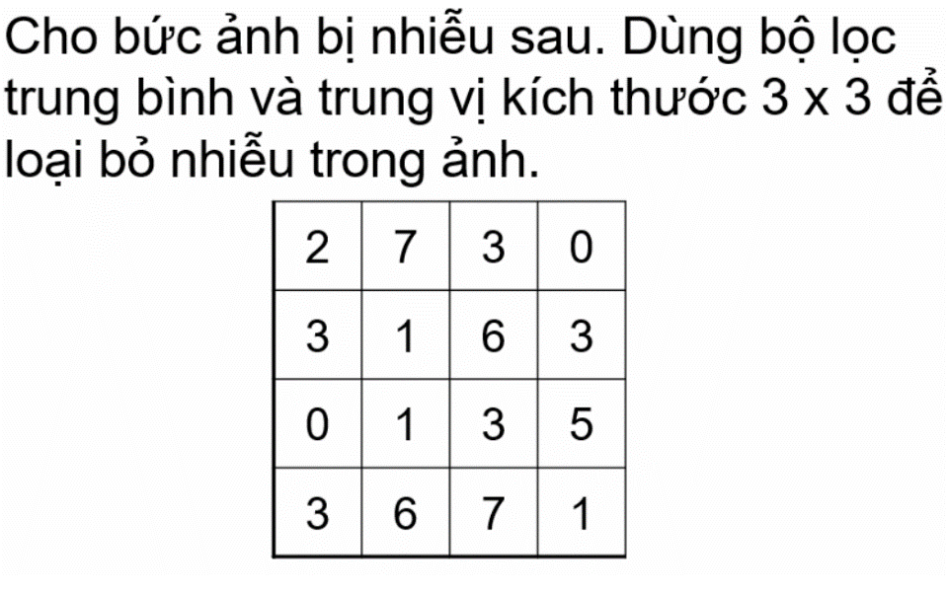

**GIẢI**

1. **Lọc trung bình**

a[1][1] = (2 + 7 + 3 + 1)/9 = 13/4 = 1.4 = 1

a[1][2] = (2 + 7 + 3 + 3 + 1 + 6)/9 = 22/9 = 2.4 = 2

a[1][3] = (7 + 3 + 0 + 1 + 6 + 3)/9 = 20/9 = 2.2 = 2

a[1][4] = (3 + 0 + 6 + 3)/9 = 4/3 = 1.33 = 1

a[2][1] = (2 + 7 + 3 + 1 + 0 + 1)/9 = 14/9 = 1.55 = 2

a[2][2] = (2 + 7 + 3 + 3 + 1 + 6 + 0 + 1 + 3)/9 = 26/9 = 2.8 = 3

a[2][3] = (7 + 3 + 0 + 1 + 6 + 3 + 1 + 3 + 5)/9 = 29/9 = 3.2 = 3

a[2][4] = (3 + 0 + 6 + 3 + 3 + 5)/9 = 20/9 = 2.2 = 2

a[3][1] = (3 + 1 + 0 + 1 + 3 + 6)/9 = 14/9 = 1.55 = 2

a[3][2] = (3 + 1 + 6 + 0 + 1 + 3 + 3 + 6 + 7)/9 = 10/3 = 3.33 = 3

a[3][3] = (1 + 6 + 3 + 1 + 3 + 5 + 6 + 7 + 1)/9 = 11/3 = 3.66 = 4

a[3][4] = (6 + 3 + 3 + 5 + 7 + 1)/9 = 25/9 = 2.7 = 3

a[4][1] = (0 + 1 + 3 + 6)/4 = 10/9 = 1.1 = 1

a[4][2] = (0 + 1 + 3 + 3 + 6 + 7)/9 = 20/9 = 2.2 = 2

a[4][3] = (1 + 3 + 5 + 6 + 7 + 1)/9 = 23/9 = 2.57 = 3

a[4][4] = (3 + 5 + 7 + 1)/9 = 16/9 = 1.78 = 2

**KẾT QUẢ**

1 2 2 1

2 3 3 2

2 3 4 3

1 2 3 2